**Group 6 2ECE-B**

**REYES, John Emmanuel ECE 2112  
ZABALA, Jude Nico**

**MACHINE PROBLEM 4**

**CODE:**

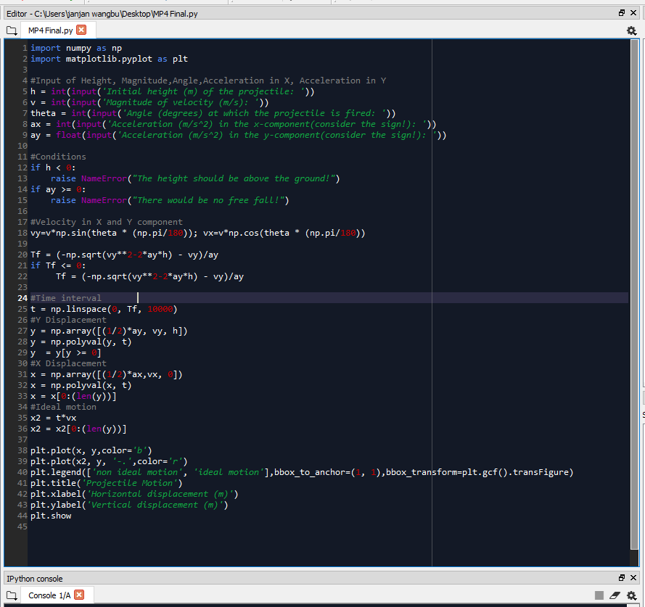

**SAMPLE OUTPUT:**

Trial 1: ax > 0

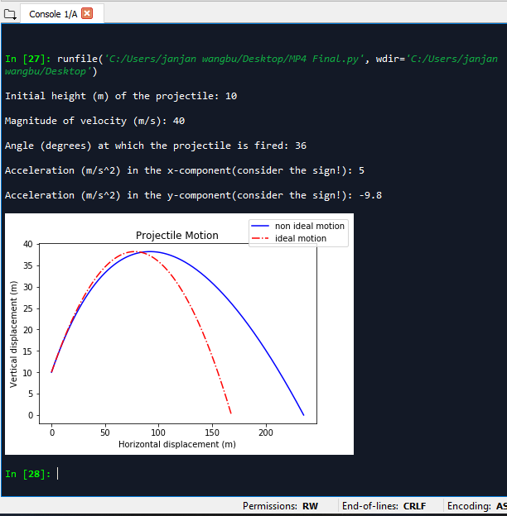

Trial 2: ax ==0

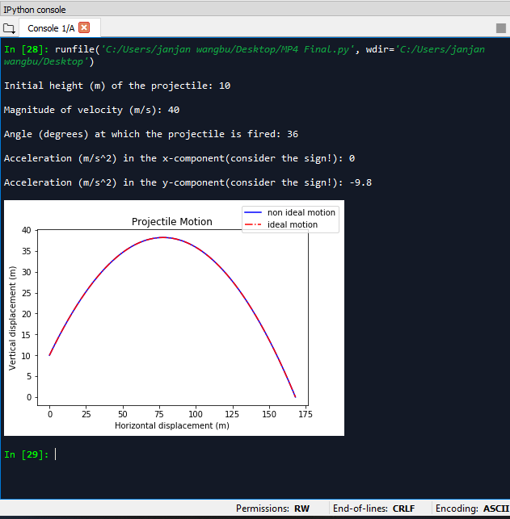

Trial 3: ax<0

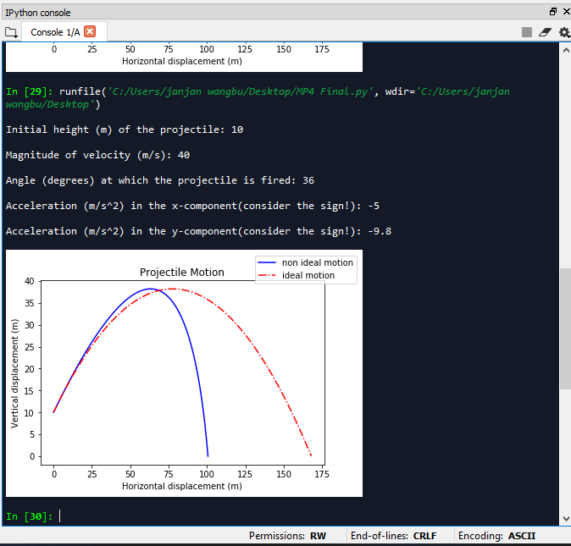

Trial 4: ay>=0 ERROR 1

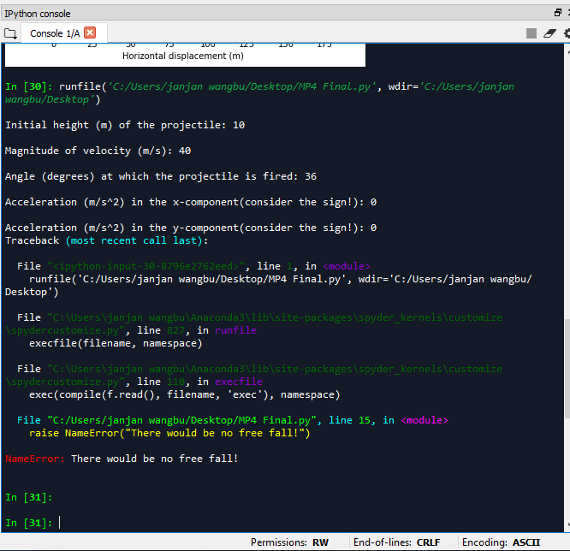

Trial 5: h<0 ERROR 2

